**Fanka Shundovska**

**JSON Homework**

**Write JSON path for:**

1. Sport question

JSON Path $.quiz.sport.q1.question

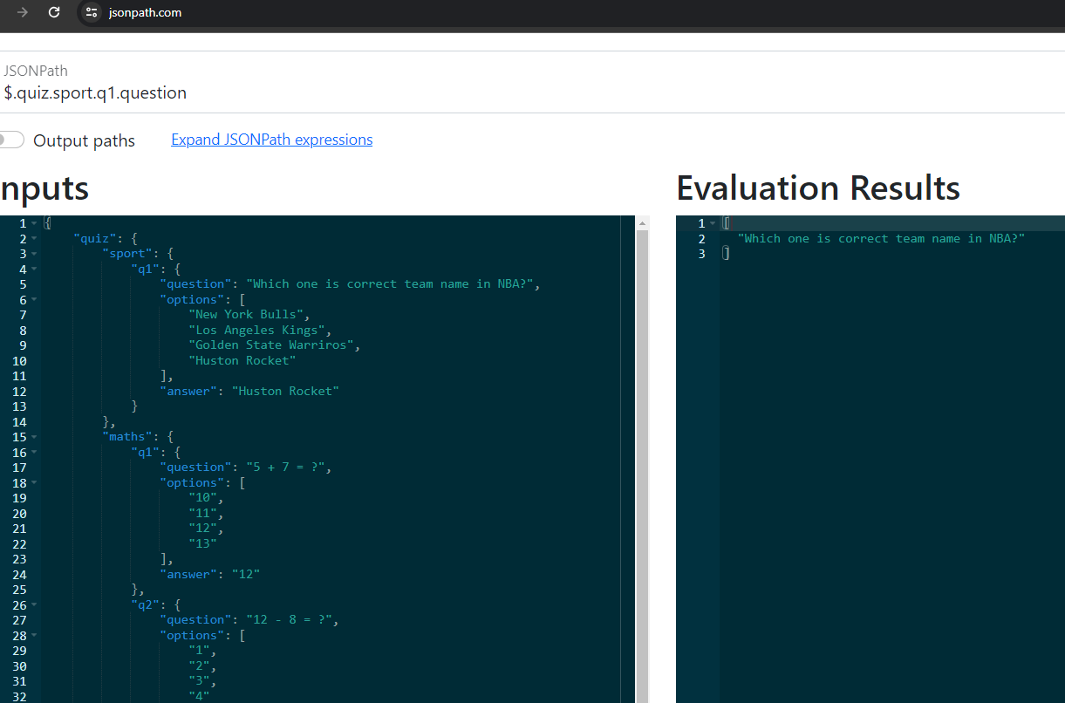

1. Options for math’s first question (q1).

JSON Path $.quiz.maths.q1.options

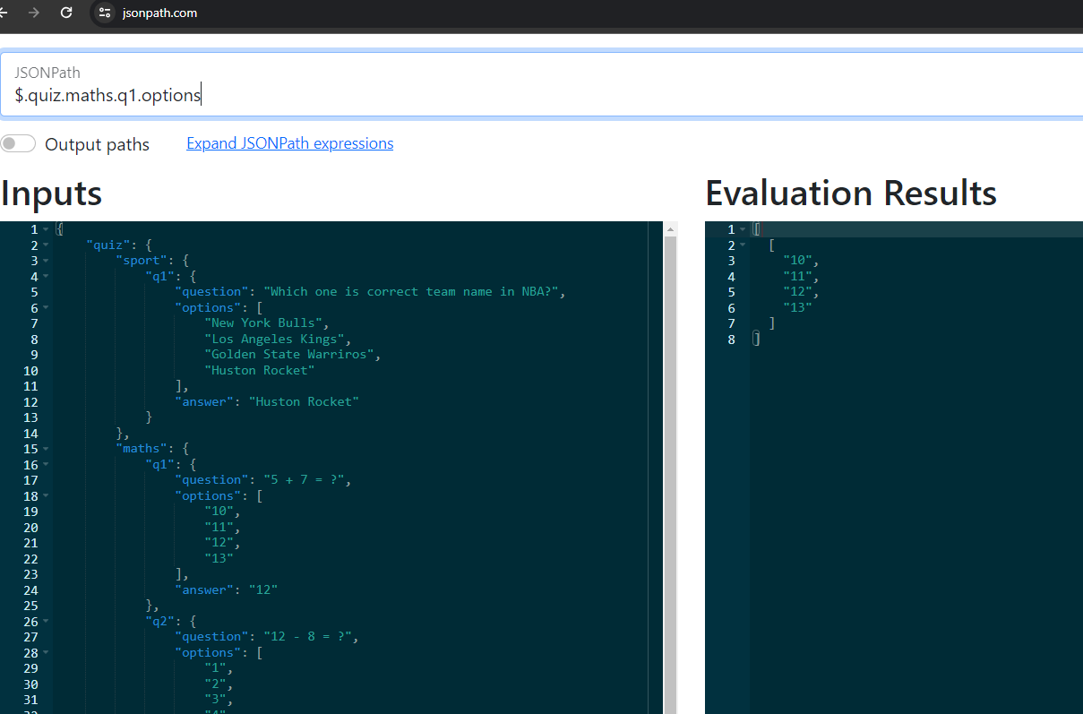

1. Answer for math’s second question (q2).

JSON Path $.quiz.maths.q2.answer

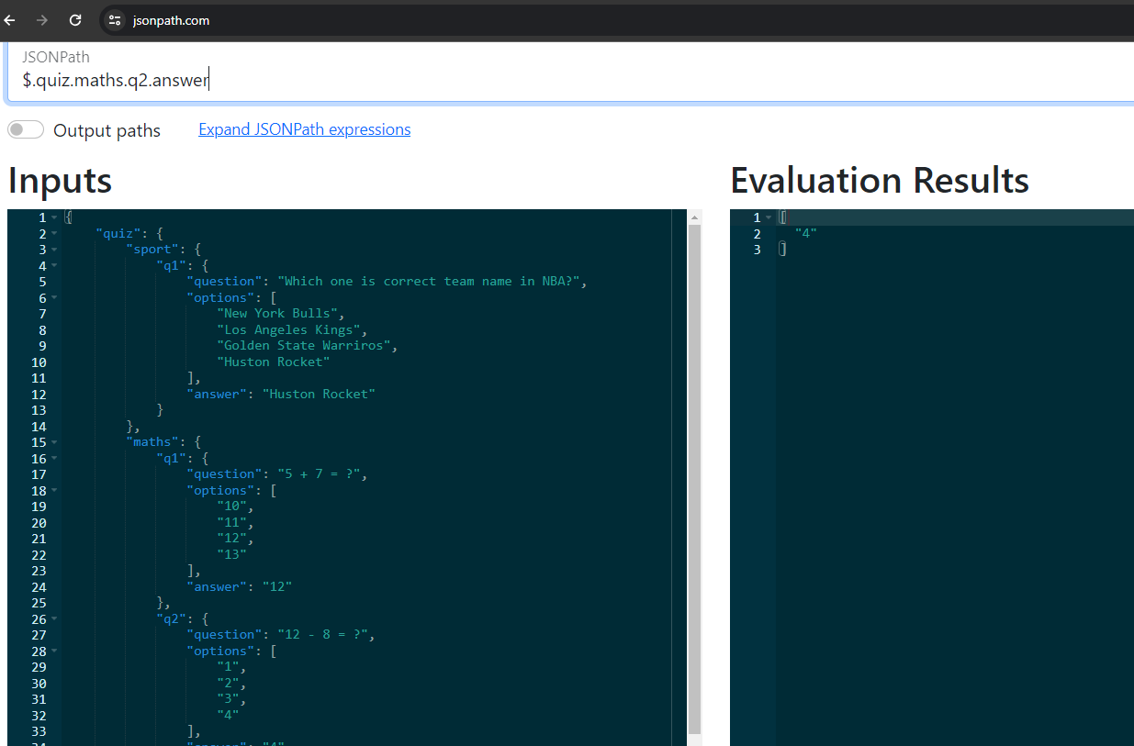

1. For all of the questions available.

JSON Path $.quiz..question

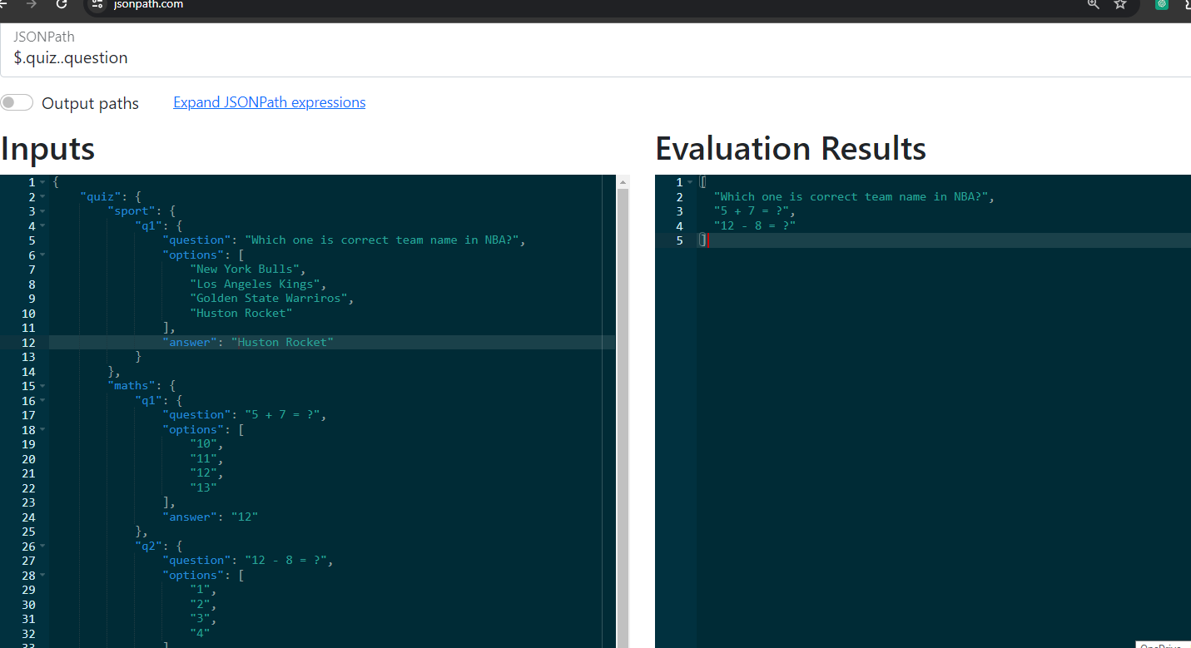

1. For all of the options available.

JSON Path $.quiz..options

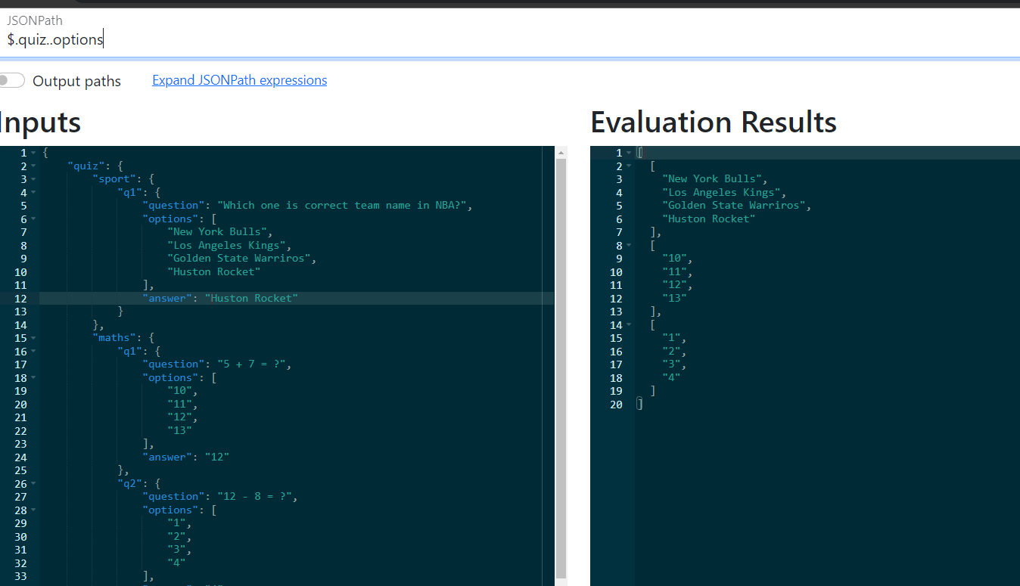

1. For all of the correct answers

JSON Path $.quiz..answer

